Ideation Phase
Empathize & Discover

Date | 06 October 2026
Team ID | SWTID-2026-9105
Project Name | Implement Client Script & UI Policy (Incident)
Maximum Marks | 4 Marks

Empathy Map Canvas – Incident Management
An empathy map is used here to understand the ServiceNow Incident user's behaviours, expectations, frustrations, and goals while creating or updating Incident records.

It helps the team identify where Client Scripts and UI Policies can reduce manual effort, improve validation, and provide a more consistent Incident experience.
Understanding the Incident user's needs helps define suitable rules for mandatory fields, automatic updates, read-only behavior, save validation, and controlled list editing.
Project Empathy Map:
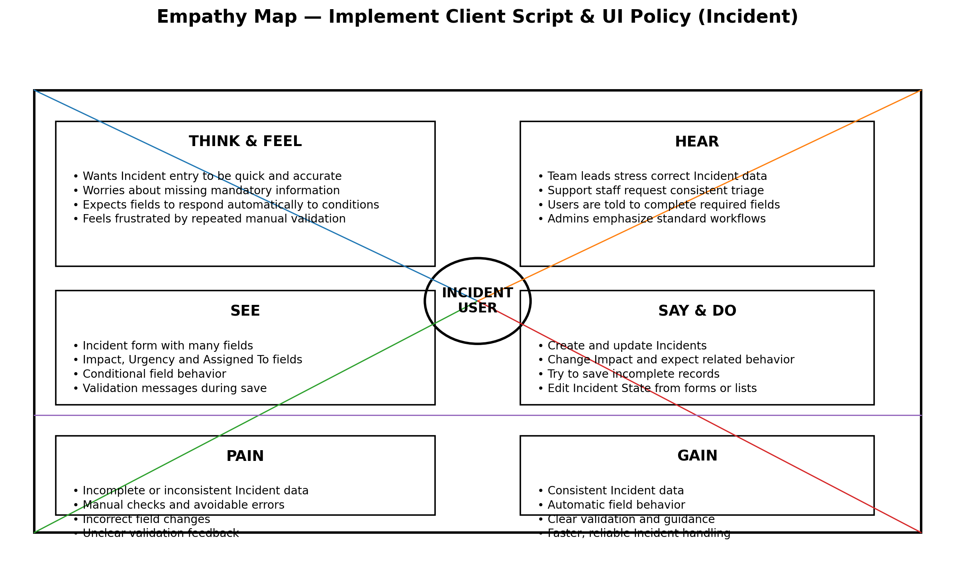

Reference: Project requirements and ServiceNow Incident implementation

Project Empathy Map: Food Ordering & Delivery Application

